Changing environment variable in Windows 10

Open control panel

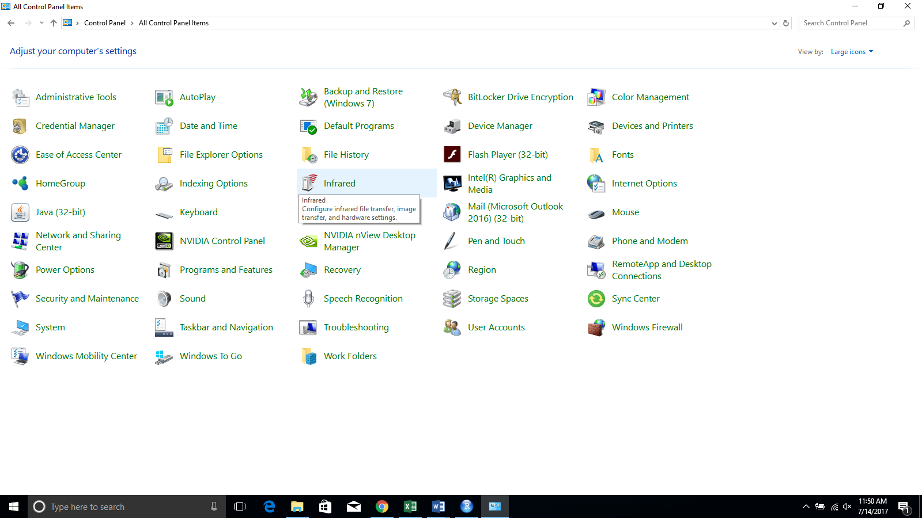

Click on System

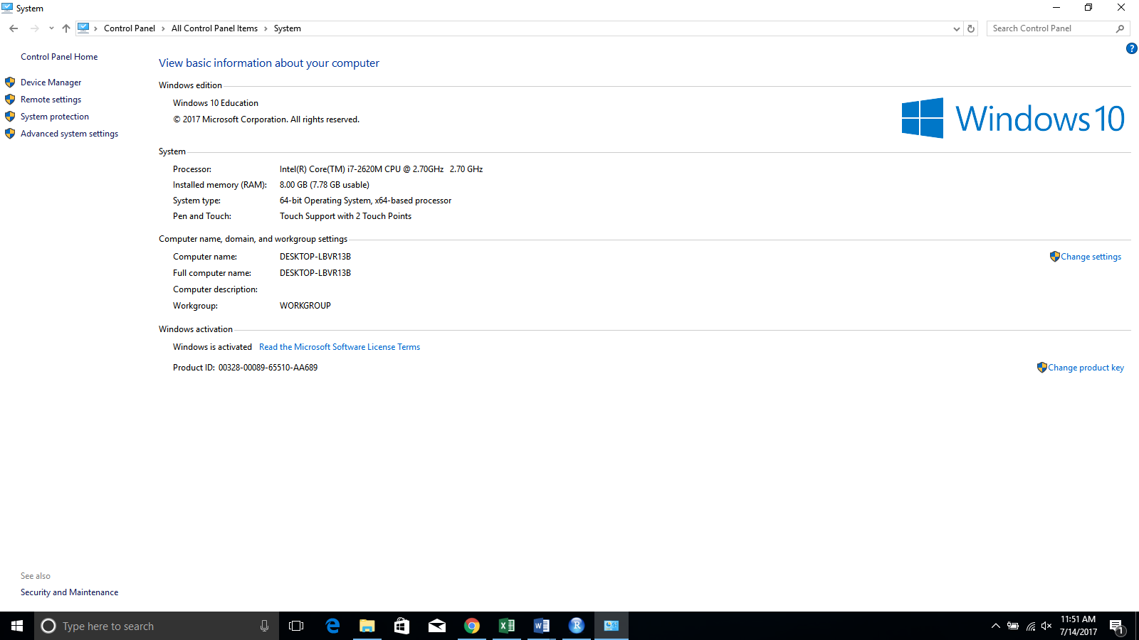

Click Advance System Settings

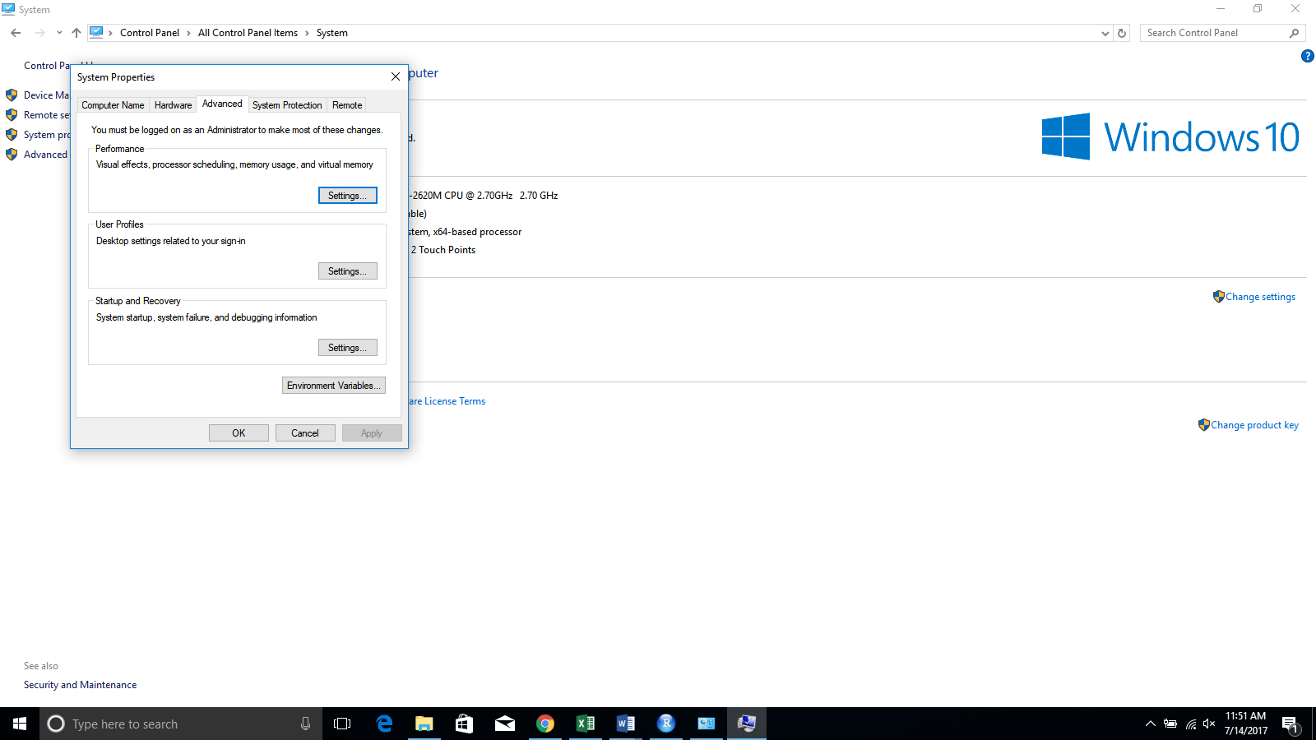

Click Environment variables

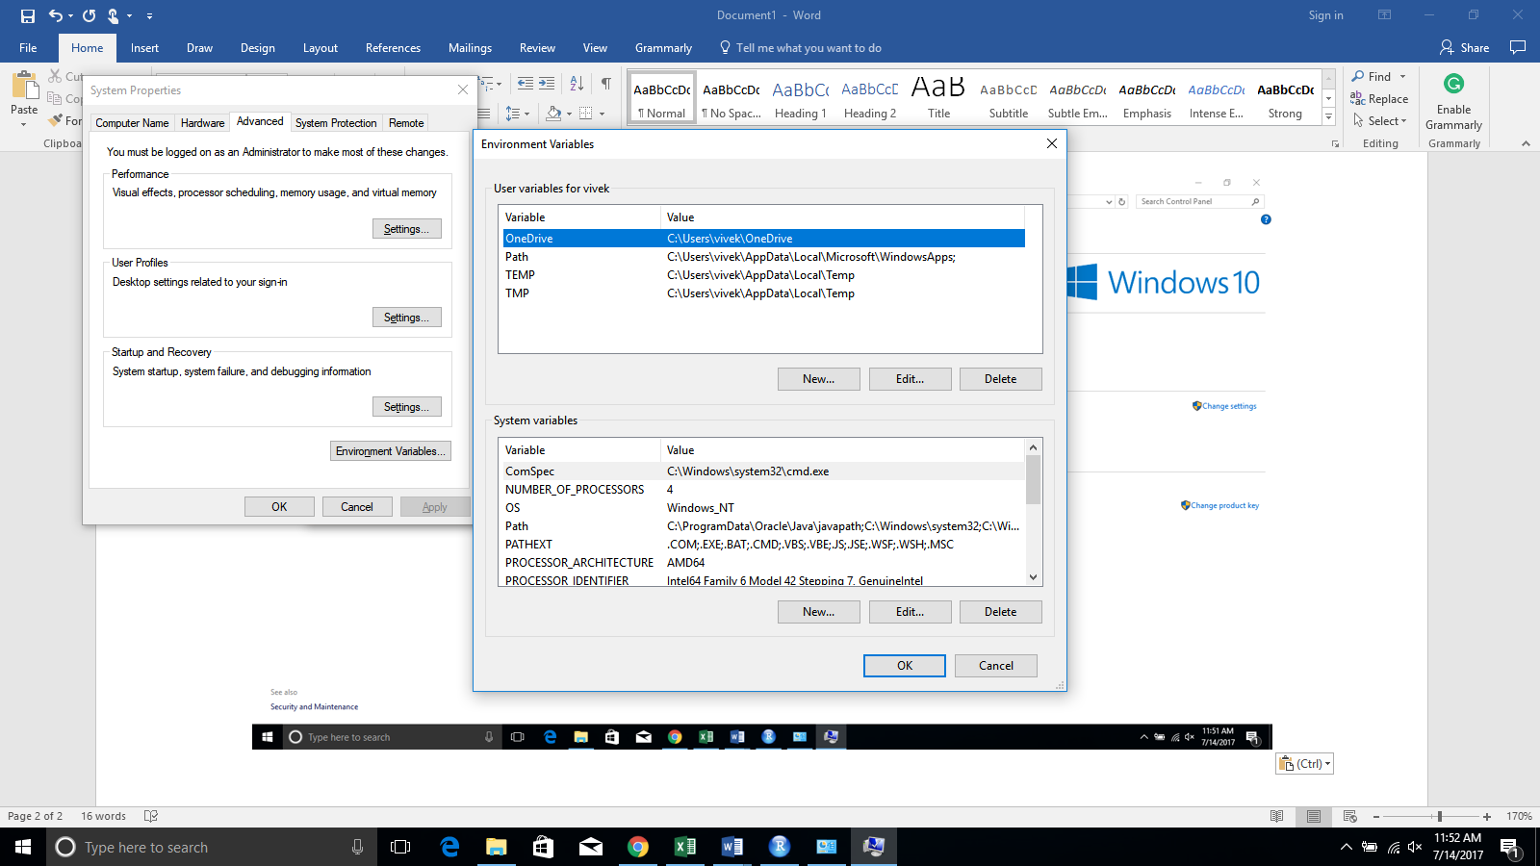

Add a new system variable ‘JAVA_HOME’